Asa Hayes CSCE-313-199 Ahmed 19 June 2020

**Report: PA3**

Part 1: Data Transfers

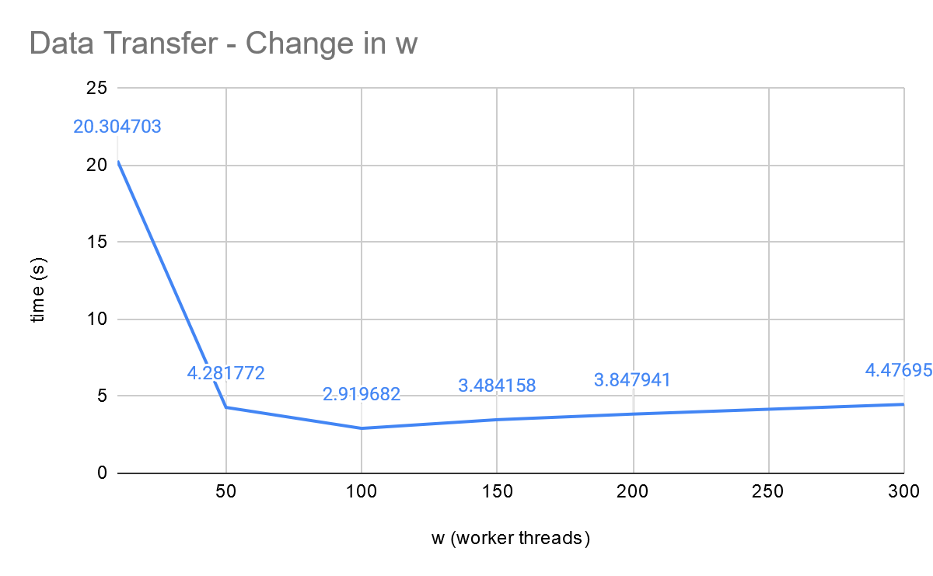

Static Values: p=5, n=15000, b=500;

In the first graph, w value provides linear time reduction with more threads up until slightly above 100. This cutoff point seems to vary with p based on other tests that had a higher threshold for where the time stopped decreasing. The reason for the eventual slowdown with more workers is likely due to the increased overhead that comes with processing and handling an excess amount of threads.

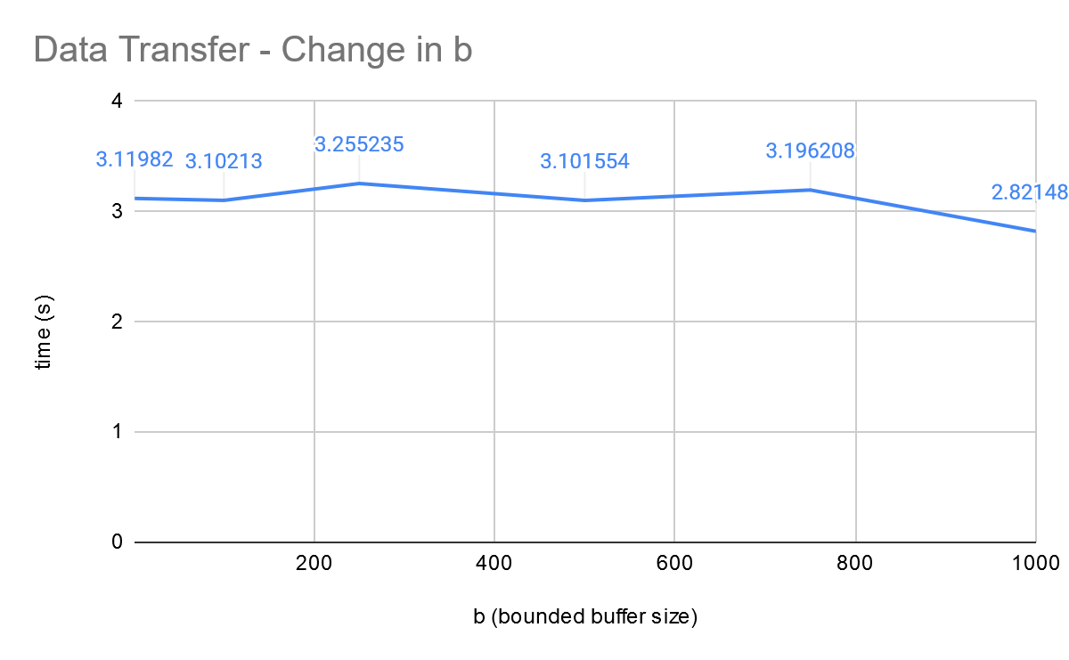

Static Values: p=5, n=15000, w=100

Time in this case seems to change relatively little with b, not varying to a significant degree up or down and only showing a slight improvement near b=1000, which soon after returns to be close to the other points. Buffer size likely doesn’t matter much, as each datapoint is a set, single length.

Part 2: File Transfers

Both tested by transferring “10.csv” like in video, parameters otherwise similar to Data transfer tests. Diff test passed, as is visible in video.

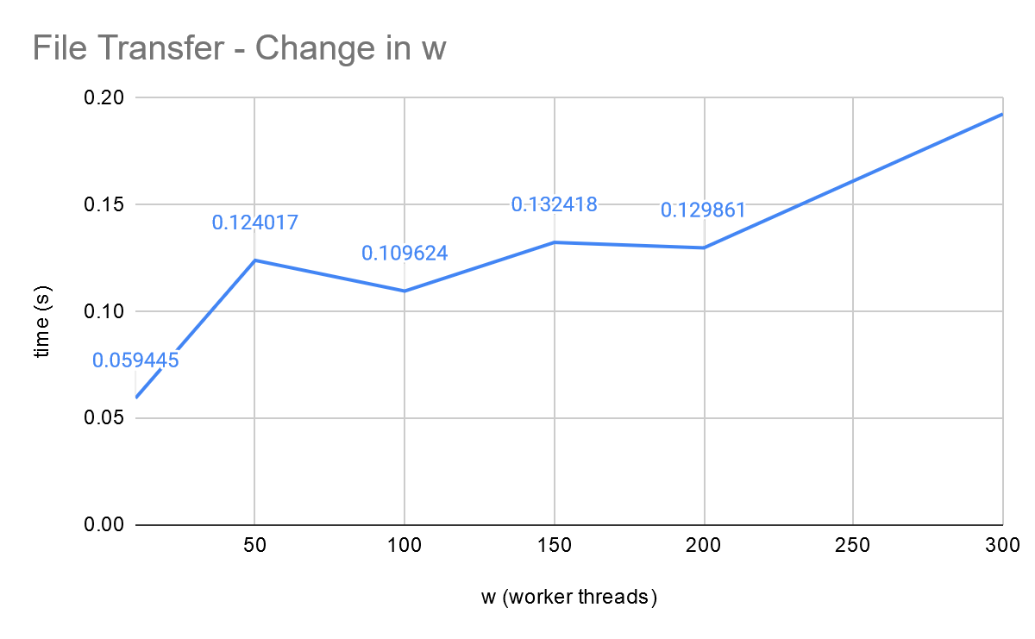

Static Values: b=500

The amount of worker threads on this makes very little difference, as a file can only be accessed and written/read by 1 thread at a time. In this case, we very quickly reach the point where more worker threads is a hindrance due to the added useless overhead.

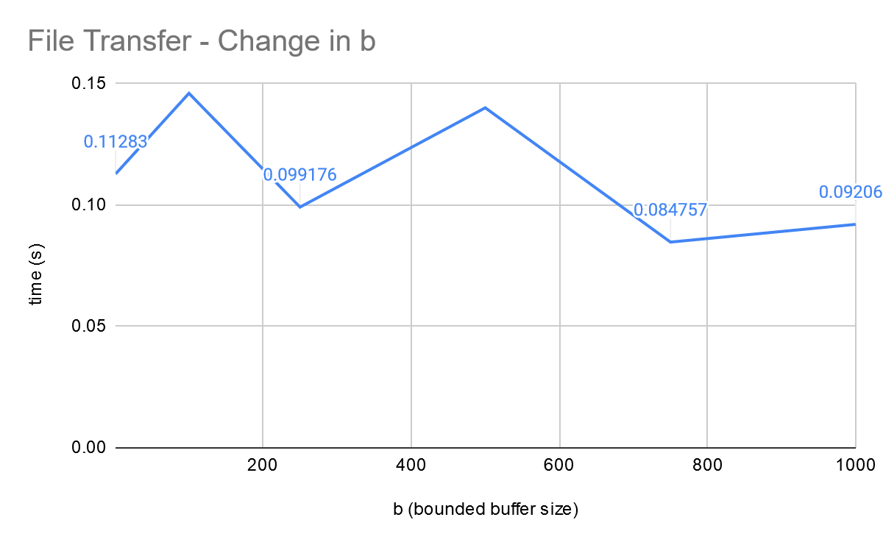

Static Values: w=100

This graph fluctuates wildly, only starting to even out near the higher values of b. My main guess for this would be something about the buffer and the filesize of 10.csv matching up up better near increments of 50 (e.g. 50, 150, 250, …). Aside from that, it certainly isn’t linear.